Red-Black tree:
It is a self-balancing binary seach tree.
Comparison of Red-Black tree with AVL Tree:
The AVL trees are more balanced compared to Red Black Trees, but they may cause more rotations during insertion and deletion. So if your application involves many frequent insertions and deletions, then Red Black trees should be preferred. And if the insertions and deletions are less frequent and search is more frequent operation, then AVL tree should be preferred over Red Black Tree.
Every node follows following rules:
- Every node has a color either red or black.
- Root of tree is always black.
- There are no two adjacent red nodes (A red node cannot have a red parent or red child).
- Every path from root to a NULL node has same number of black nodes.

Don’t read anymore in this: Wasted 8 hours
Some important points about red-black tree:
- Color of a NULL node is considered as BLACK.
- Tools for insertion or deletion: Recoloring and rotation
- When a black node is deleted and replaced by a black child, the child is marked as double black.
Insertion in Red-Black tree:
Perform standard BST insertion and make the color of newly inserted nodes as RED. Suppose the newly inserted node is x. Now there are three conditions:
- If the level of x is 1 (means x is root node): change color of x as BLACK (Black height of complete tree increases by 1).
- If the level of x is 2 (means the parent of x is root node): No problem. The black height of the tree remains unchanged.
- If the level of x is more than 2: Two conditions:
3.1: If x’s uncle is RED:
(I) Change color of parent and uncle as BLACK.
(ii) color of grand parent as RED.
(iii) Change x = x’s grandparent, repeat steps 1, 2 and 3 for new x.
3.2: If x’s uncle is BLACK: Do AVL rotation and apply the following rule:
Level of uncle of inserted element is made red. Its upper and lower level is made black.
Deletion in Red-Black tree:
In delete, the main violated property is, change of black height in subtrees as deletion of a black node may cause reduced black height in one root to leaf path. To understand deletion, notion of double black is used. When a black node is deleted and replaced by a black child, the child is marked as double black. The main task now becomes to convert this double black to single black.
To delete a node from the red-black tree, perform standard BST delete. When we perform standard delete operation in BST, we always end up deleting a node which is either leaf or has only one child (For an internal node, we copy the successor and then recursively call delete for successor, successor is always a leaf node or a node with one child). So we only need to handle cases where a node is leaf or has one child. Let v be the node to be deleted and u be the child that replaces v (Note that u is NULL when v is a leaf and color of NULL is considered as Black). Three cases may occur:
- If either u or v is red: We mark the replaced child as black (No change in black height).
- If Both u and v are Black: Color u as double black. Then six cases will arise (If in any case, the number of black nodes in each path on the left hand side of the figure is not equal, means the extra required black nodes must be present there in the sub-tree which is hidden):

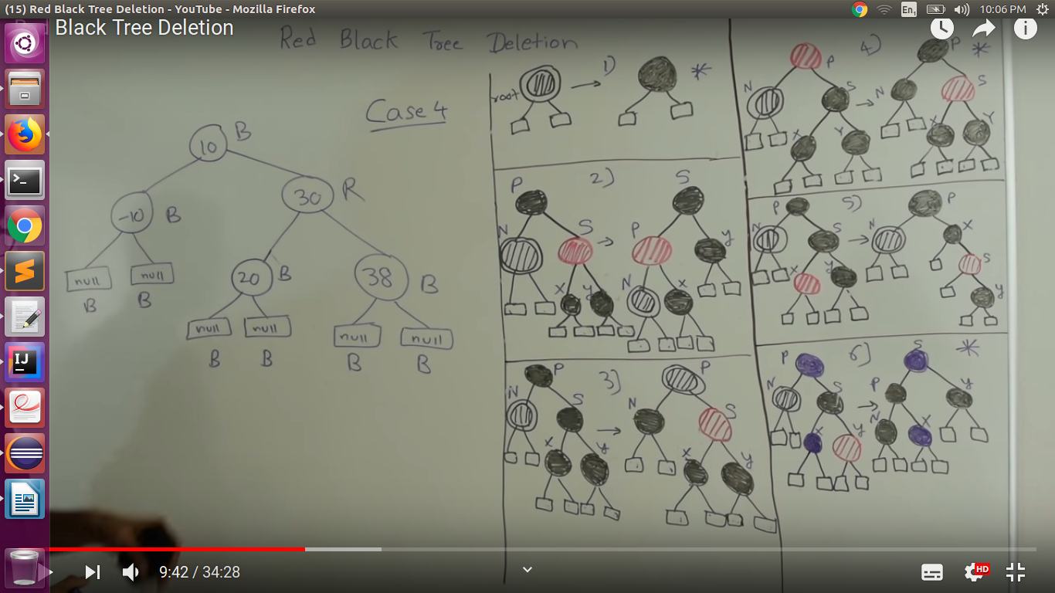
For more details: https://www.youtube.com/watch?v=CTvfzU_uNKE

